

*Russian Cat Interest Group of SA*

*BLUE. BLACK. WHITE. BLUE SPOTTED TABBY.*



**ISSUE 7**

**Our Breed Homes**

**Leanne Hewitt - Azreal Russians and Carol Wood - Silversheen Russians pretty much took over from Stephanie Eboral – Warwick Russians. Both Leanne and Carol started breeding in 2004 and in 2006 Stephanie moved back to England. Stephanie still breeds Russians in England under the same prefix Warwick Russians.**

**In 2010/2011 our litte group of breeders grew to four breed homes in South Africa, with the addition of, Alma – Esky Russians and Saskia – Ruskia Russians. In the past two years to date, four additional breeders have signed up with the RCIG to help us preseve the breed.**

**For now though and after the 2015/2016 season, Saskia – Ruskia Russians will take leave for a while to focus on her family. We used Spirit and Bustopher extensively during this season and both boys will be neutered in the coming weeks. Bustopher will go to his new forever home soon, Spirit however will stay with Saskia as a pet. Saskia will keep Sylvie her Blue female entire with the option to breed her again in the future. I would like to thank Saskia for her contribution to our beautiful breed and wish her, Chris and little Nathan only special and wonderful things in life. Saskia, we hope to see you back here at some point, to continue your work with the Russians. But for now enjoy the kittens, your family and some rest……….**

**RCIG NEWS**

**Hello all RCIG Members,**

**Spring has arrived, as well as our first 2015/2016 Russian Kitten Litters.**

**Leanne and Saskia kicked off the season with new borns, well done to both breeders and Queens. We also have 3 Russian Black kittens in the mix of Russian Blues and in October we are also expecting Alma’s Russian White girl to produce her first litter and hope to welcome a few Russian White babies into the world. We sincerely hope to see many of these new babies on our show benches throughout SA in 2016.**

**To the Russians that made it into the Regional Top Cat Shows around South Africa – WELL DONE! What a great achievement, not only for the cats but also for their breeders.**

**Vader, our Russian Black boy who has been residing with Saskia at Ruskia Russians in Natal since he was 3 months old, has been relocated to the Western Cape and will be a permanent fixture with Joelene at Zingara Russians.**

**Thank you to each and every one of you, (our Breeders) for your passion, dedication and hard work. Without you, we would not have Russians!**

Russians Rule!

**October 2015**

**Russian & Siamese Rescue Cats**

**On the 1st September Persian/Exotic & Sphynx Rescue S.A. and Raise ‘n Rescue collected Silversheen Captain Silver Andrei and Tiger the Siamese from a woman who gave them up even threatened to abandon them at a shelter or SPCA. I met the two boys at our local vet once they were in safe hands with the Raise ‘n Rescue foster. Both were tested for FIV and FeLV and both came back as negative. I covered the costs for the testing and on Tuesday 22nd September both cats went to their new forever home. They were adopted together and live with a retired couple who is besotted over them.**

**My sincere thanks go to both Persian/Exotic & Sphynx Rescue as well as Raise ‘n Rescue as well as their new family.**

***Silversheen Captain Silver Andrei***

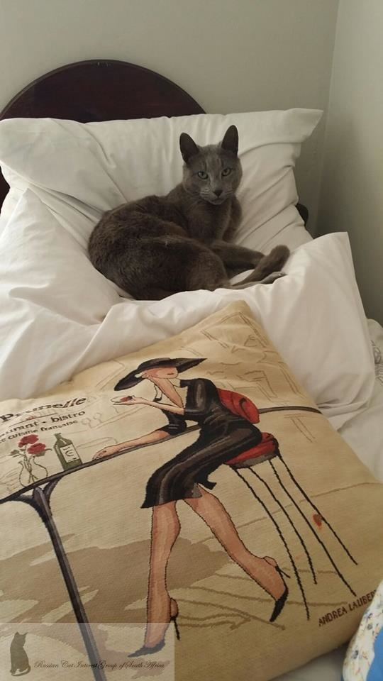

**Kimi at the Cape Top Cat Show 26th September 2015**

**Sp Ch Azreal Nikimara Narulah R.Q. aka. Kimi was invited to participate in the Cape Top Cat 2015. As per usual, the Kimi supporters were there to root for our Russian and to our absolute surprise and a happy one too, Kimi came in as 3rd best entire cat on show. Simply outstanding! Well done Kimi and Leanne. Last year his famous mother Eviee won at the Cape Top Cat Show.**

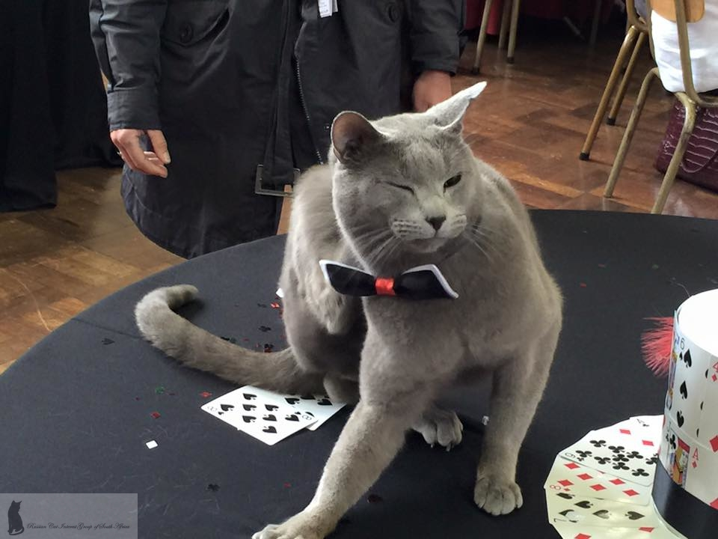

***Sp Ch Azreal Nikimara Narulah R.Q. aka. Kimi***

**Lolly one of our team and fellow Russian cat owners arranged to have shirts printed for us, which we proudly wore on Saturday.**

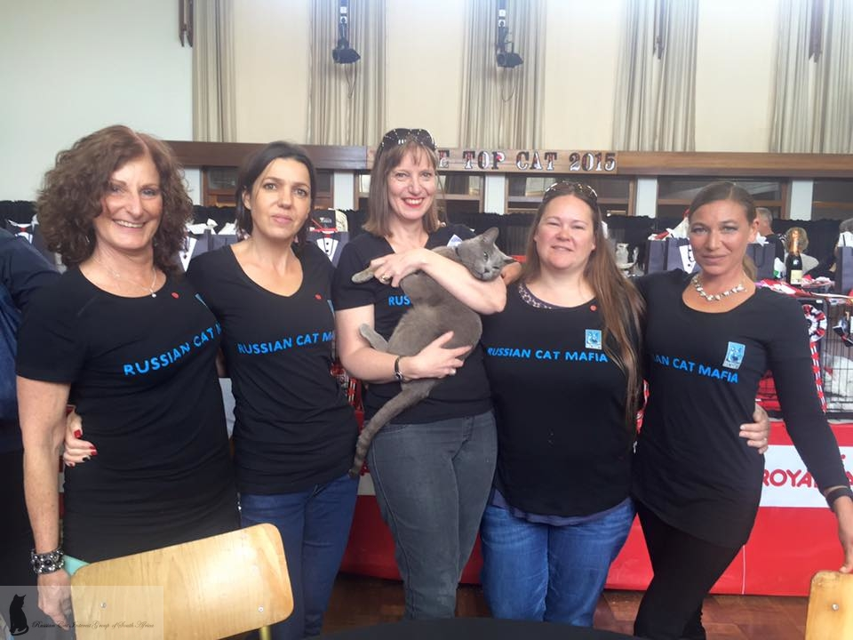

***Russian Cat Mafia support team: Lolly, Solly, Janet with Kimi, Joelene & Leanne***

Russian Blue - Russian Black - Russian White Russian Blue Spotted Tabby

!



**2015/2016 Kitten Season**

**Kitten season is now in full swing. 3 Litter have been born this September and another 3 Litters are expected in October, 4 further litters are expected in November, and possibly another 2 or so litters in the New Year.**

**If you are not on a waiting list as yet and you are thinking of getting another Russian, please get into contact with our breeders or myself.**

**Russian kittens are not sold on a first come first serve basis; there are processes in place, which our breeders and the RCIG are very strict about.**

**Rooibos Tea for Itches**

**If you notice that your cat is scratching so much that they are starting to draw blood and you know for a fact it has nothing to do with fleas. Do your cat and yourself a favour, by just making ordinary Rooibos Tea allow it to draw and cool down.**

**Take some cotton wool, soak it in the Rooibos tea and dab it onto the affected area, soak it if you like. You can do this twice a day for two days and the itch will be gone, the area will scab up and heal.**

**What Commercial Food should I Feed my Cat?**

**There are many brands of cat food on the market some are good and others not so good. We suggest that you follow through with your breeders recommendations, which are:- Royal Canin, Hills Science Diet, Acana or Orijen. All brands are available from your vet.**

**What Cat Litter is Best?**

**There is nothing better than Cats Best Litter. Cats Best is an imported product. Please see who your local supplier in your area is.**

***Continue from previous………***

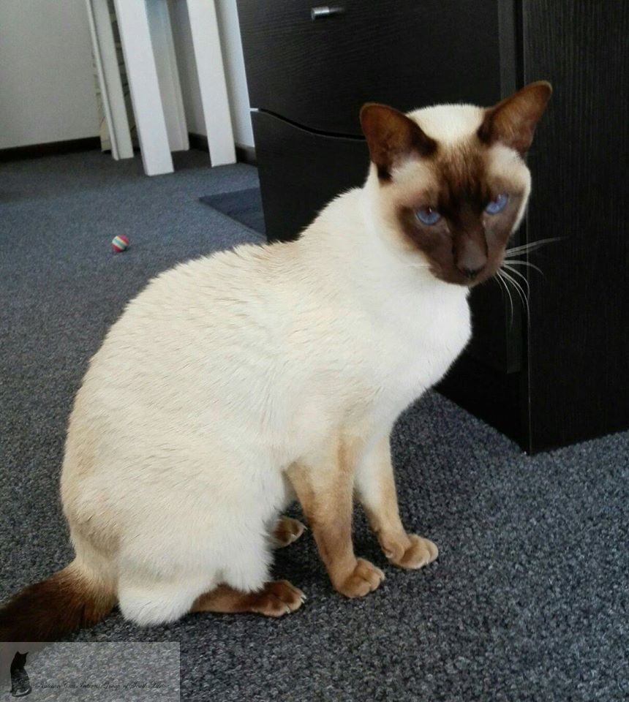

***Tiger the Rescue Siamese***

**We wish both cats and their new owners well.**

**Show Cat Titles**

**In our last Newsletter we talked about Cat Titles and the difference between Champions and Premiers and in this edition we will cover Best in Show, Regional and National titles.**

**Any cat can be Best in Show on the day of the show, in other words the (winner on show day).**

**Best in Show (BIS)**

**Regional Qualifier (R.Q)**

**Regional Winner (R.W.)**

**National Qualifier (N.Q)**

**National Winner (N.W)**

**The Regional and National Qualifiers or Winners get to add R.Q or N.Q after their registered name and if they win Regional or National Shows they also add R.W or N.W after the registered name of the cat.**

All Russian’s are Neutered/Spayed, Vaccinated and Micro-chipped before they go to their new Pet Home…….



**Russian Cat Interest Group Membership Fee**

**Our annual membership fee will be going up in January 2016. The fee has been R30.00 per annum or R300.00 for a Life membership (10 years), since October 2012. In January 2016 the membership fee will go up to R40.00 per annum or R400.00 for a Life membership (10 years). The membership fee is for the person not the cat/s, no matter how many cats you own the annual membership fee will remain R40.00 per annum.**

**Please ensure that you all paid up and that the RCIG has all your Russians details. Please do remember to send RCIG your new address or contact details, and also when you add a new Russian.**

**Our membership application will be attached to the same e-mail in which the newsletter will be sent out.**

**Did you know???**

1. **Cats can't taste sweets.**
2. **A cat's tongue consists of small "hooks," which come in handy when tearing up food.**
3. **Americans spend more annually on cat food than on baby food.**
4. **In 1987 cats overtook dogs as the number one pet in America.**
5. **A group of youngsters (kittens) is called a kindle; those old-timers (adult cats) form a clowder.**
6. **The catgut formerly used as strings in tennis rackets and musical instruments does not come from cats. Catgut actually comes from sheep, hogs, and horses.**
7. **Black cat superstitions are as American as apple pie. In Asia and England, black cats are considered lucky.**
8. **Cats have five toes on each front paw, but only four toes on each back paw.**
9. **Cats have true fur, in that they have both an undercoat and an outer coat.**
10. **When a domestic cat goes after mice, about one pounce in three results in a catch.**

**Cat Language**

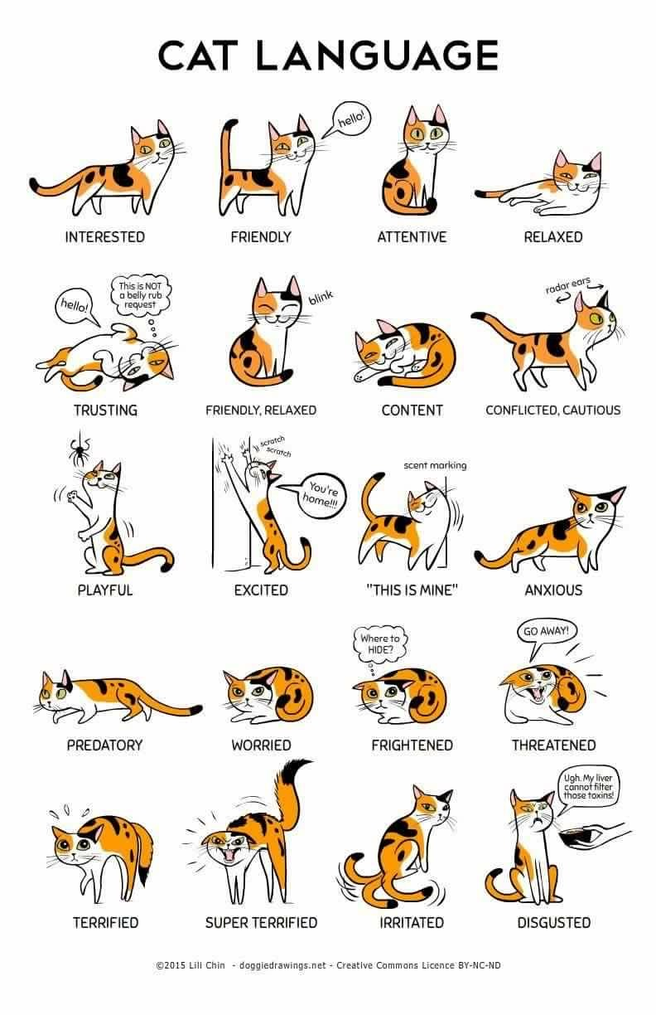

**RCIG Constitution**

**We have recently made some changes to the RCIG Constitution. You can view our Constitution on our website:-**

[**http://rcig.weebly.com/documents--forms.html**](http://rcig.weebly.com/documents--forms.html)



Russians make good babysitters………..



**Cat Humour**

[](http://www.google.co.za/url?sa=i&rct=j&q=&esrc=s&source=images&cd=&cad=rja&uact=8&ved=0CAcQjRxqFQoTCPn1yIbjmcgCFQVcFAodn9sNAA&url=http://chickgeek.org/kitty-archaeologist/&psig=AFQjCNEVMXcOrEPIjj3P7H2h0b38y9QUxA&ust=1443531094662049)

**Picture watermarks**

***NB. I would like to make each of you aware that I have decided to put a RCIG Logo watermark onto all pictures that we use in our Newsletters going forward. The watermarks don’t suggest that the images were photographed by me, but rather by the RCIG members and breeders. We need to protect the images of your Russians or other kitties, from scammers using them as their own.***

***Please feel free to add your own watermarks to your images in future…………https://www.watermark.ws/***

**Our Newsletter is made available every February, June and October, by e-mail, Facebook and Issuu.com**

**-x-**

**RCIG Committee Members**



**Our committee members & breeders are as follows:-**

**Alma Pretorius (Esky Russians)**

[**almapretorius@gmail.com**](mailto:almapretorius@gmail.com)

**Carol Wood (Silversheen Russians)**

[**silversheenc@gmail.com**](mailto:silversheenc@gmail.com)

**Krystle Callaghan (Kriss Cross Orientals & Russians)**

[**krystle@krisscross.co.za**](mailto:krystle@krisscross.co.za)

**Laurelle Abnett (RCIG)**

[**lmabnett@iafrica.com**](mailto:lmabnett@iafrica.com)

**Leanne Hewitt (Azreal Russians)**

**Justin Hewitt (Azreal Russians)**

[**leanne@perform.co.za**](mailto:leanne@perform.co.za)

**Chris Vet (Ruskia Russians)**

**Saskia Vet (Ruskia Russians)**

[**sask@webmail.co.za**](mailto:sask@webmail.co.za)

**Solveig Klahr (RCIG)**

[**solveig.rcig@gmail.com**](mailto:solveig.rcig@gmail.com)

**Should you wish to contact us, please do not hesitate.**

**Regards your RCIG Team**

Russians own you – You are their slave…..

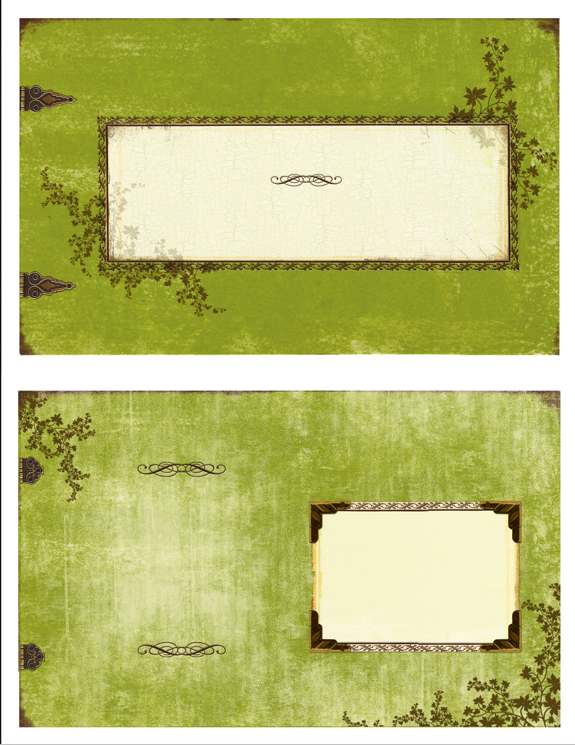



**Editor Solveig Klahr**

**083 272 2443**

[**solveig.rcig@gmail.com**](mailto:solveig.rcig@gmail.com)

For Russian Cat Interest Group Members, follow us on Facebook

[**https://www.facebook.com/groups/RCIGroup/**](https://www.facebook.com/groups/RCIGroup/)

**Or on the Web**

[**http://rcig.weebly.com**](http://rcig.weebly.com)

**https://www.facebook.com/groups/russiansrule/**

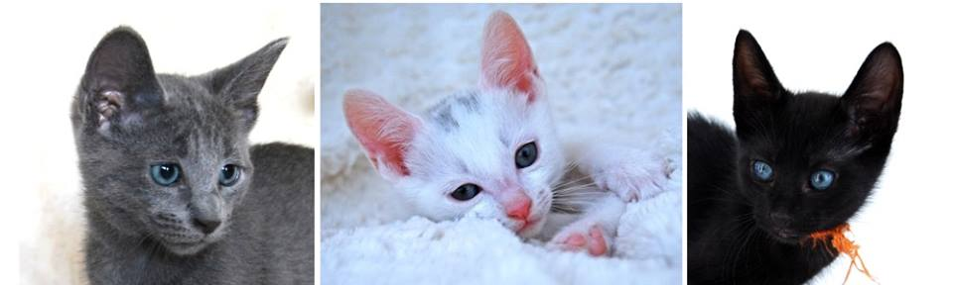

***Before you purchase a pedigree kitten/cat, please spend time researching the breed and make sure that you approach an Ethical, Reputable & Responsible Breeder. Purchase cat magazines, visit the website*** [***http://www.kittensandcats.co.za/***](http://www.kittensandcats.co.za/) ***and see who the registered breeders are or call the SACC Registrar Johan van Rooyen to find out who the Ethical breeders are. 011 616 7017-*** [***http://www.tsacc.org.za/***](http://www.tsacc.org.za/) ***Please ask as many questions as you can possibly think of when dealing with the breeder of your chosen breed. We want to stand together against BYB as they breed “fruit salad” cats, harm their breeding cats, and simply don’t care about anything as long as they make money of often sick, unaltered and underage kittens.***

***Share this info with your family and friends.***