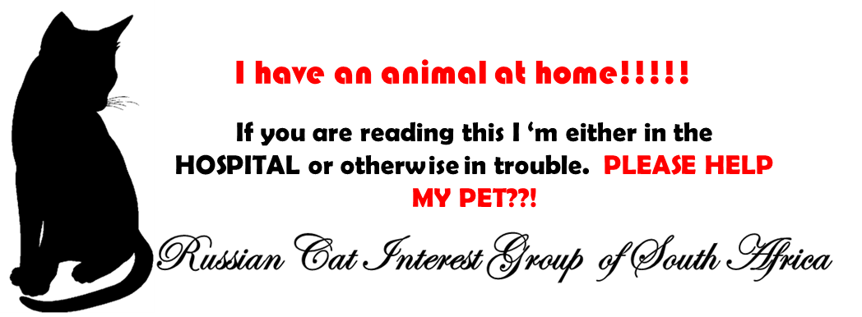
My Name is:

I have:

Pets Name (s):

Either contact a person who can care for my pets until I come home, or call the following people to assist:-

Name 1: Phone No:

Name 2: Phone No:

Please PRINT and keep in your wallet.

For the love of our pets ………

